**Nursing Tab content**

**Banners**

**1**

**Where Nursing Skills Meet Scale:**

Hands-On Nursing Training from Primary Care to Super Speciality with 3000+ Bedded Hospitals

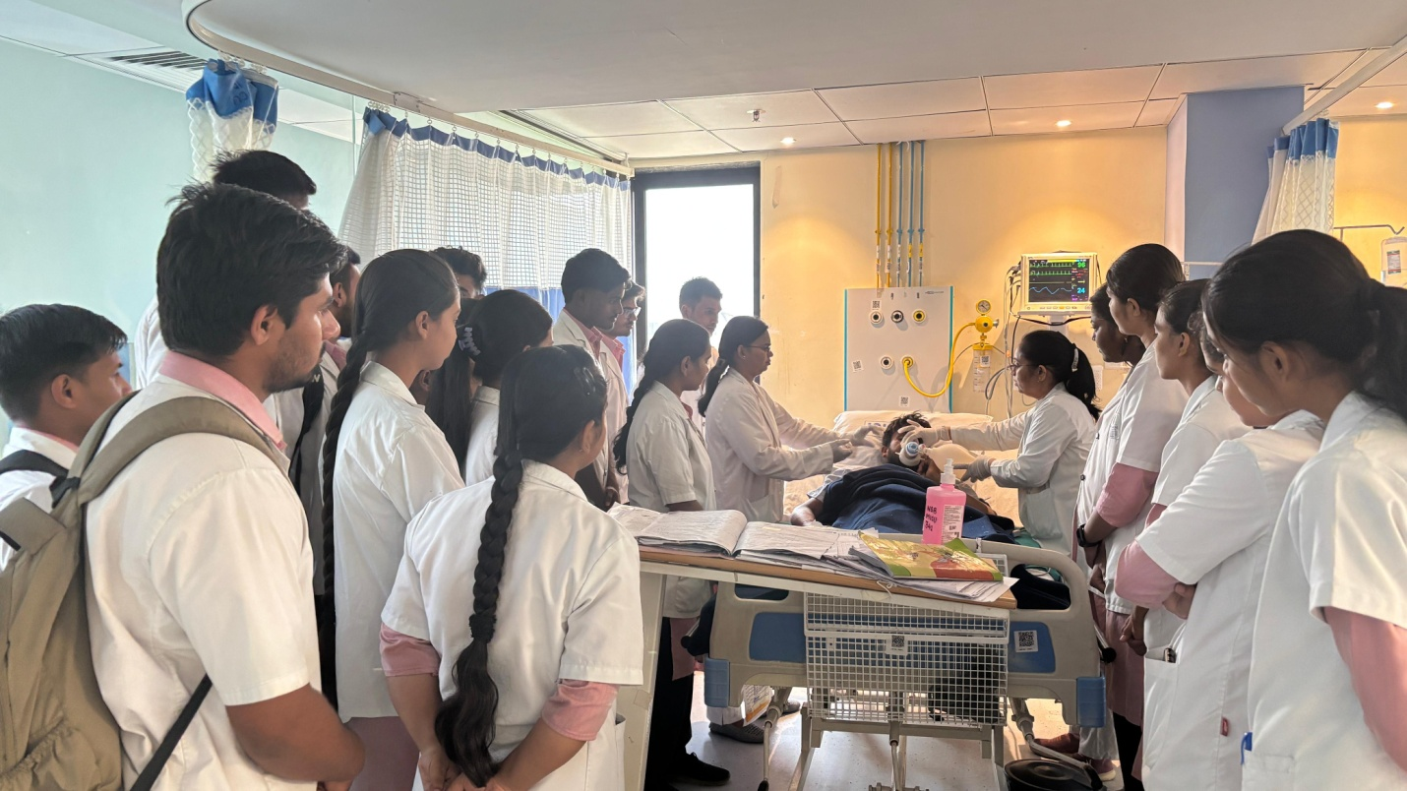

**2**

**Master Clinical Excellence:**

Advanced Skill Labs, OSCE Training, High-Fidelity Mannequins & Specialized Maternal Health Labs  
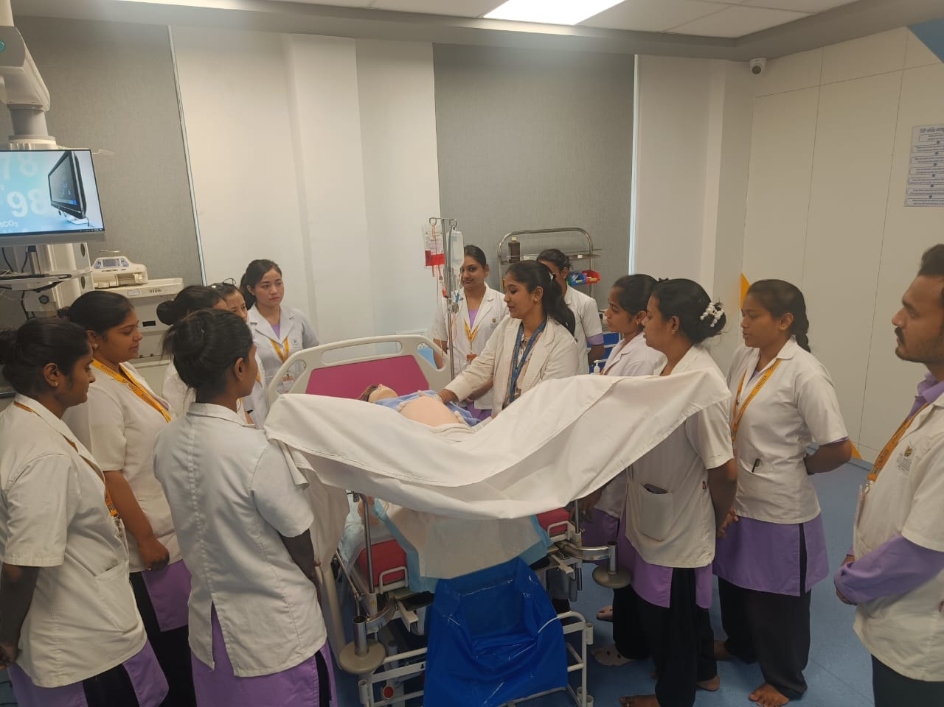

**3**

**From India to Abroad:**

International Externships and Placements at Renowned Institutions like NIMHANS, Tata Memorial, and UKE Hospital, Germany

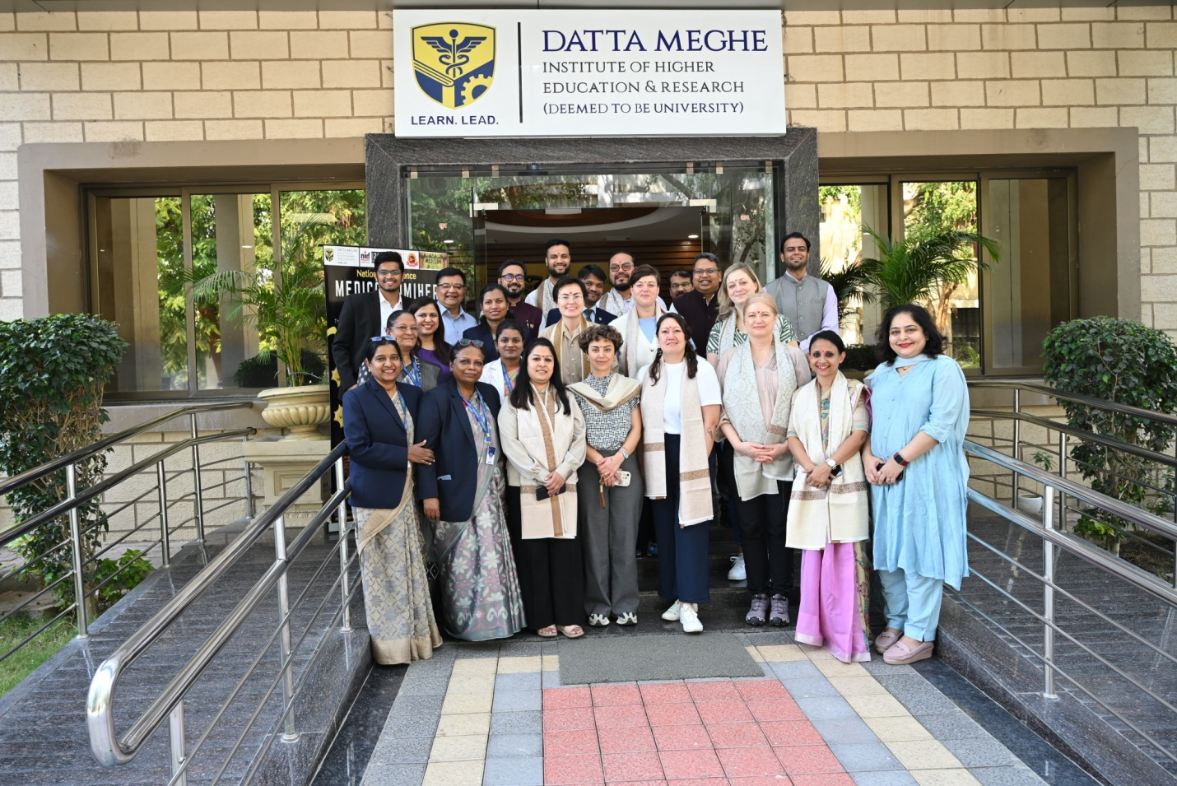

**4**

**Your Merit, Our Support:**

Multiple Merit-Based Scholarships and Financial Assistance

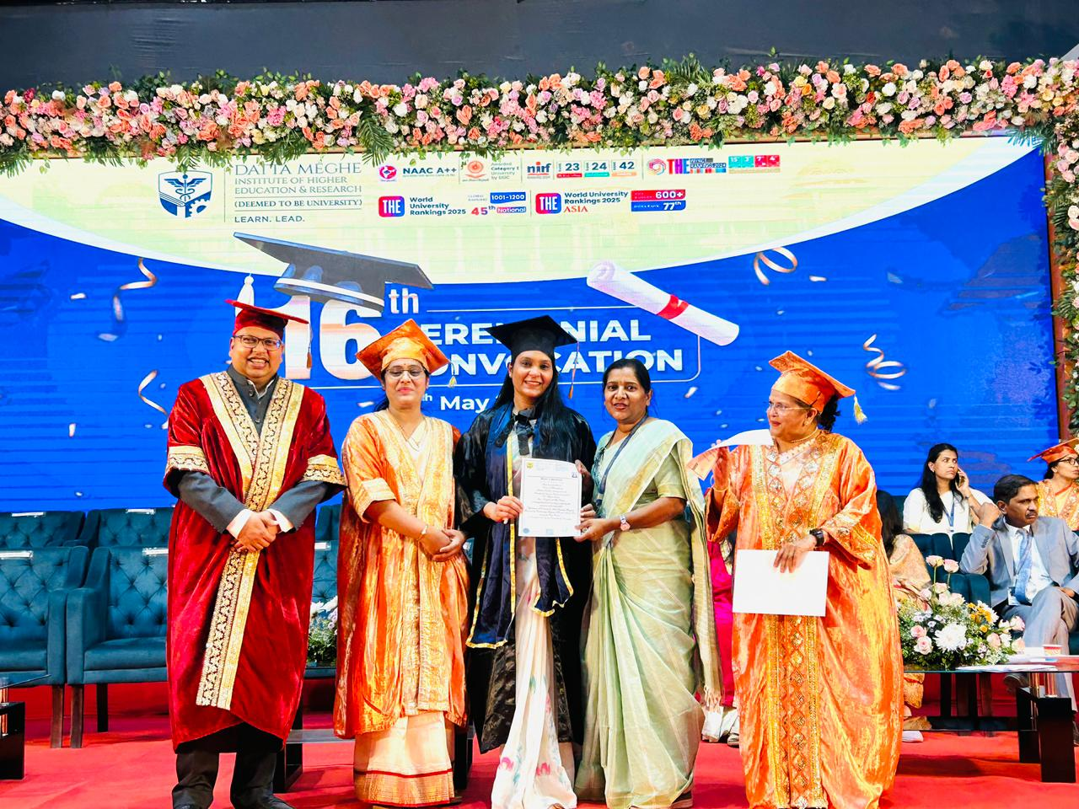

On page content

At DMIHER, nursing isn’t just a profession—it’s a calling. Our colleges of nursing across ~~Nashik,~~ Wardha and Nagpur ~~Nagpur and Wardha~~ embrace a shared purpose: to empower nurses with the skills, compassion, and courage, through hands-on training, global collaborations, and a deep commitment to research and innovation.

**Highlights**

**The DMIHER Nursing Advantage**

Highly Qualified & Experienced Faculty with Ph.D. qualifications and 15+ years of teaching and clinical experience ensuring academic and practical excellence.

Hands-on exposure through CHCP integrating preventive, primary, mental, and social services for holistic nursing skills.

The institution supports meritorious students through prestigious scholarships, including TNAI, Lila Poonawalla Foundation, and Rajshri Shahu Maharaj Scholarships, fostering academic excellence and financial accessibility

Collaborations with international and national adjunct faculty, driving innovation and research in nursing.

100% placement assistance and job readiness support for seamless global healthcare opportunities.

Strong support for **student and faculty research** with 1500+ publications in reputed indexed journals such as **Scopus, Web of Science, PubMed, PubMed Central, BMJ, Medknow, Elsevier, and Wiley.**

Next section

A brief intro to our Nursing colleges

We have a horizontal scroll section, on click so we will see three buttons but only one college visual and text will be visible, as we click or scroll, the other college and then the other appears along with the respective building image and title of the college.

(Please maintain this sequence for all the sections of this page)

Smt. Radhikabai Meghe Memorial College of Nursing, ~~Nashik~~ Wardha

Shalinitai Meghe College of Nursing, Salod (Hirapur), Wardha

Shalinitai Meghe College of Nursing, Nagpur

There will be a short intro content for each one.

**Smt. Radhikabai Meghe Memorial College of Nursing (SRMMCON), Wardha**

Established in 2002, SRMMCON pioneered Postgraduate Nursing in Vidarbha and has consistently elevated standards in nursing education. Integrated with DMIHER in 2009, it has earned the highest NAAC ‘A++’ grade (CGPA 3.78), reflecting its unwavering commitment to academic rigor and excellence. From foundational B.Sc. programs, to advanced Post Basic B.Sc. Nursing, Post Basic Diploma, Postgraduate Nursing and PhD nursing, SRMMCON blends hands-on clinical training with a forward-thinking curriculum. Its stellar legacy and pursuit of transformative healthcare education make it a destination of choice for aspiring nursing leaders.

Know more

**Shalinitai Meghe College of Nursing (SMCON), Wardha**  
Established in 2023, Shalinitai Meghe College of Nursing (SMCON), Wardha, offers a B.Sc. Nursing program dedicated to developing skilled, compassionate professionals. As a constituent of DMIHER (Deemed to be University), recognized with NAAC ‘A++’ and UGC Category-I status, SMCON operates with the highest academic and professional standards. Approved by the Maharashtra Nursing Council, the program integrates evidence-based nursing practice with technological advancements, supported by extensive clinical exposure at Shalinitai Meghe Super Speciality Hospital. Rooted in the values of Acharya Vinoba Bhave and Mahatma Gandhi, SMCON fosters a culture of professionalism, empathy, and service.

Know more

**Shalinitai Meghe College of Nursing (SMCON), Nagpur**  
Established in 2023, SMCON, Nagpur, offers 100 B.Sc. nursing seats annually, with a focus on evidence-based learning, dedicated mentorship, and global academic perspectives. As a constituent of DMIHER (Category-I Deemed to be University), it provides students with the advantage of modern infrastructure and access to advanced multispecialty and super-specialty services at Shalinitai Meghe Hospital & Research Centre. SMCON Nagpur is committed to shaping competent, compassionate nursing professionals, equipping them with the skills and mindset required to thrive in a dynamic healthcare landscape.

Know More

**Next section**

Leadership Team and Principal’s message

Put all the Principal messages along with visual and designation. Keep all three next to each other.

Message Sequence of the is first SRMMCON than SMCON

**Message from the Principal – SRMMCON, ~~Nashik~~ Wardha**

Welcome to **Smt. Radhikabai Meghe Memorial College of Nursing (SRMMCON)**, where we are committed to excellence in nursing education, research, and clinical practice. Our state-of-the-art facilities, experienced faculty, and student-centered approach ensure holistic development, preparing future nursing professionals to meet global healthcare challenges.

Know More

Dr**.** Vaishali Taksande (Chahande) **Professor cum Principal, SRMMCON**

PhD in OBGY Nursing,

M.Phil.in HPE  
M.Sc. Nursing in OBGY nursing,

and B.Sc. Nursing

[principal.srmmcon@dmiher.edu.in](mailto:principal.srmmcon@dmiher.edu.in)

**Message from the Principal – SMCON, Salod, Wardha**

It is my privilege to welcome you to Shalinitai Meghe College of Nursing, Salod, (Hirapur) at Datta Meghe Institute of Higher Education and Research (Deemed to be University) Wardha. SMCON Nursing college excellence in healthcare education, and dedicated to nurturing skilled, compassionate, and knowledgeable professionals who will contribute meaningfully to the healthcare sector.

Dr. Ranjana Sharma

Principal, SMCON, Wardha

M.Sc. Nursing, M. Phil, Fellowship, PhD.

Medical Surgical Nursing

principal_smconbsc@dmiher.edu.in

Know More

**Message from the Principal – SMCON, Nagpur**

Welcome to Shalinitai Meghe College of Nursing, a premier institution shaping future nursing leaders. Established in 2023 under DMIHER (DU), we are committed to academic excellence, hands-on clinical training, and holistic student development.

Nursing is more than a profession—it’s a calling. We equip our students with cutting-edge knowledge, ethical values, and compassionate care, blending theory with practical exposure in top healthcare institutions. Our state-of-the-art facilities, research-driven curriculum, and global standards ensure graduates exceed industry expectations

Principal Name:- Dr. Nilima Rakshale

Institute Name:- Shalinitai Meghe College of Nursing, Nagpur

Qualification:- Ph.D. in Mental Health Nursing

Email ID:-

Principal.smconnagpur@dmiher.edu.in

**Next section**

Programs Make a design similar to the Program links, here put only the three institute names as click

UG I PG I Diploma I Phd

**Next section**

Hospital section. We will show the hospitals for each college on click

**Affiliated Hospitals**

**SRMMCON**, Wardha

The teaching hospital serves as a dynamic learning hub for nursing students, offering hands-on experience across diverse healthcare settings. Guided by experienced professionals, students actively engage in patient care, diagnostics, and therapeutic procedures, developing essential skills and clinical competence.

Link AVBRH hospital

Link Community Outreach & Social Responsibility

**SMCON (WARDHA)**

The teaching hospital at SMCON provides immersive clinical training, exposing students to diverse medical and surgical services. Guided by experienced professionals, students develop critical thinking, clinical competence, and hands-on skills essential for their nursing careers.

Link to the hospital Shalinitai Meghe Super Speciality Hospital, Wardha

Link Community Outreach & Social Responsibility

**SMCON (NAGPUR)**

The teaching hospital provides extensive hands-on training in diverse medical and surgical settings, fostering critical thinking, clinical competence, and professional growth. Students gain practical skills and real-world insights under expert guidance, preparing them for excellence in patient care.

Link to the hospital Shalinitai Meghe Hospital & Research Centre, Nagpur

**Next section**

**Holistic Learning and Infrastructure**

**Teaching-Learning Facilities**

Technology enabled classrooms, smart boards, high-end projectors, Wi-Fi enabled campus I Competency-Based Education I Simulation-based learning, VR/AR-enabled education, High-fidelity mannequins, LMS, mandatory modules, self-directed learning (SDL) I AETCOM modules I Coursera courses, electives, Standardized Patient Programs (SPP) I Research and Innovation Hubs

**Laboratory & Hospital Facilities**

Advanced Simulation Lab with lifelike mannequins I OSCE Lab I Nutrition Lab I Community Health Nursing Lab I Maternal and Child Health Lab I Pre-Clinical Lab

**School of Experiential Learning & Simulation Centre (SEL & SC) and Museum**

Simulations, skill stations, anatomical models, and historical and contemporary healthcare innovations.

**Library Facilities**

Extensive collection of academic texts, research papers, and clinical guides I Digital access to journals, e-books, and research databases such as PubMed and others I Study zones, group workspaces, and computer stations I Access to DELNET’s vast repository of e-resources, research papers, and academic materials from multiple institutions I Digital Lab: Access to extensive e-resources including Springer, ProQuest, EBSCOHOST, NDLI, Shodhganga, E-Shodhsindhu, and the British Council Digital Library.

**Students Guidance and Counselling Center**

Providing mental health resources, stress management support, and wellness programs

Next Section

A visual section with following links:

1. Transcripts – UG & PG

Know More

1. Electives Offered

Know More

We will not have the departments section, as showing only one college feels imbalanced. This will get covered for the know more of the institute at the beginning.

***Next section***

Research & Collaborations

**Research & Collaborations**

**Advancing Nursing Knowledge**

With a deep commitment to advancing nursing knowledge, our research focuses on evidence-based practices and critical healthcare challenges. Through national and international collaborations, we are shaping the future of nursing education and patient care.

* **Research Publications:** 1,513
* **Intellectual Property Rights:** 86
* **Copyrights:** 70 - SRMMCON
* **National Awards:** 37
* **International Awards:** 10
* **Collaborative/Funded Projects:** Karlstad University (Sweden), Erasmus Women Entrepreneurship, Glasgow Caledonian University (Scotland, UK), and Enprendia.

**Thrust Areas**

Evidence-based nursing, maternal health, malnutrition, mental health and adolescent psychiatry, communicable and non-communicable diseases, rural health, reproductive and child health, innovations in nursing education, informatics, and educational technology.

Next section

**Global Opportunities**

Through partnerships with institutions like UKE Hospital, Hamburg, students gain global exposure and placements. Over 25 SRMMCON students have already secured conditional appointments in Germany, marking the beginning of their international healthcare journeys.

Add logos and pictures

Next section

Higher education and Placement

Only keep a link, as applicable to only one college

Student Life

Testimonials

At DMIHER, we, global collaborations, and a commitment to societal betterment.

We have to make a combined page for all three institutions.

Make three top banners, each one mentioning one collage. However, keep the spirit of Nursing at DMIHER at the core of all three headlines. Reflect that. State that.

Use the below content to create the headlines.

The below content is a mixed content and may or may not be applying to all collages, so craft keeping that in mind.

Next, use the below content to create the intro content for nursing a short paragraph only. Follow that up with the way we create the barebones content as highlights. So, don’t put everything in the intro paragraph.

1. **Comprehensive Community Health Care Program (CCHCP)**

The institute provides comprehensive community health care programs which are integrated approaches that combine preventive, primary, mental and social services to improve overall well-being and social needs of a community. These programs provide practical experience that are crucial for building a well-rounded nursing skill set.

1. **Advanced Skill Lab & OSCE Training for Clinical Excellence**  
   The institution provides **cutting-edge facilities**, including an **OSCE (Objective Structured Clinical Examination) Training Center**, **Advanced Skill & Simulation Labs** equipped with **high-fidelity mannequins**, and **specialized nursing and maternal health labs**, ensuring hands-on clinical excellence.
2. **Scholarships & Financial Aid:** Lila Poonawala scholarship based on merit list and need based, Trained Nurses Association of India (TNAI) based on merit list, selected by TNAI committee, Rajarshi Chhatrapati Shahu Maharaj Shikshan Shulkh Shishyavrutti Yojna, and DMIHER-specific financial aid programs.
3. **Innovation & Research Focus:** Drives advancements in patient care, healthcare practices, and nursing education.
4. **Clinical Training & Mentorship:** Hands**-**on learning under experienced mentors to refine practical skills and patient care techniques**.**
5. **Collaborations & Externship Programs:   
   Our Institutions** partner with renowned **national and international healthcare institutions** for clinical externships and global career placements, NIMHANS, Wadia Maternal and Children's, Rashtra Sant Tukadoji Maharaj Cancer Rehabilitation Centre, Tata Memorial Hospital, The National Cancer Institute, and Sri Sathya Sai Sanjeevani Center for Child Heart Care and UKE Hospital, Hamburg, Germany.
6. **Adjunct International & National Faculty**  
   **Our Institutions** are in collaboration with **7 international** and **6 national adjunct faculty members**, enriching the academic environment with global expertise and advanced research perspectives.
7. **Career Support & Placements**  
   With 100% placement assistance, our nursing institutions facilitates job fairs, internships, and abroad training, ensuring seamless career opportunities with top-tier healthcare institutions worldwide.